

**National College of Ireland**

**Project Submission Sheet – 2021/2022**

|  |  |  |  |
| --- | --- | --- | --- |
| **Student Name:** | Dylan Brennan…………………………………………………………………………… | | |
| **Student ID:** | X18119859……………………………………………………………………………………… | | |
| **Programme:** | Bachelor of Science Honours in Computing | **Year:** | 4…………… |
| **Module:** | Cloud Application Development………………… | | |
| **Lecturer:** | Dr. Keith Maycock………………………………………………………………… | | |
| **Submission Due Date:** | 09/12/2022…………………………………………………………………………………… | | |
| **Project Title:** | Noticeboard…………………………………………………………………………………… | | |
| **Word Count:** | ……………………………………………………………………………………………………………… | | |

I hereby certify that the information contained in this (my submission) is information pertaining to research I conducted for this project All information other than my own contribution will be fully referenced and listed in the relevant bibliography section at the rear of the project

ALL internet material must be referenced in the references section Students are encouraged to use the Harvard Referencing Standard supplied by the Library To use other author's written or electronic work is illegal (plagiarism) and may result in disciplinary action Students may be required to undergo a viva (oral examination) if there is suspicion about the validity of their submitted work

|  |  |
| --- | --- |
| **Signature:** |  |
| **Date:** | 09/12/2022………………………………………………………………………………………… |

**PLEASE READ THE FOLLOWING INSTRUCTIONS:**

1 Please attach a completed copy of this sheet to each project (including multiple copies)

2 Projects should be submitted to your Programme Coordinator

3 **You must ensure that you retain a HARD COPY of ALL projects**, both for your own reference and in case a project is lost or mislaid It is not sufficient to keep a copy on computer Please do not bind projects or place in covers unless specifically requested

4 You must ensure that all projects are submitted to your Programme Coordinator on or before the required submission date **Late submissions will incur penalties**

5 All projects must be submitted and passed in order to successfully complete the year **Any project/assignment not submitted will be marked as a fail**

|  |  |
| --- | --- |
| **Office Use Only** | |
| Signature: |  |
| Date: |  |
| Penalty Applied (if applicable): |  |

Table of Contents

Introduction 2

Development Strategy 2

Database Design 2

Implementation 2

Design Patterns 2

Testing 2

Deployment, Continuous Integration and Delivery Strategies 2

# Introduction

A digital noticeboard, containing posts of flexible types which might be found in public spaces such as post offices and shops. Common examples of posts which might be found on such a noticeboard include rooms for rent, tutoring services available and a bicycle for sale. Users can create noticeboard for their local area and being creating posts on these noticeboards. The application will have three user types, an owner type user who creates a board and a standard user who may post on the board. The owner will have additional permissions and controls over the content posted on the board. The other user type is me as the administrator with full permissions over all content & functionalities of the system.

The system will make use of two external gems, devise [1] will be used for user authentication throughout the system. The faker gem [2] will be used to create dummy data to aid in development and testing. Two external data feeds will be used to generate a post on each noticeboard, a “word of the day” type post using the Merriam-Webster dictionary API [3] and a weather report post based on the location of the noticeboard, utilizing the API from OpenWeatherMap.org [4].

# Development Strategy

## Database Design

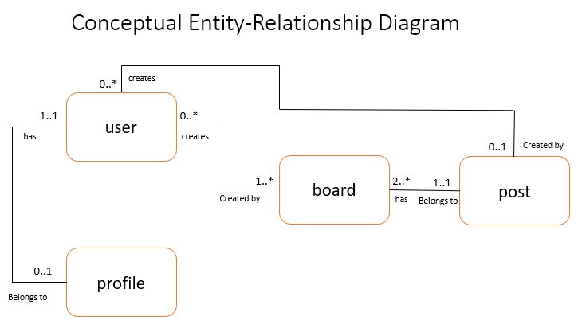

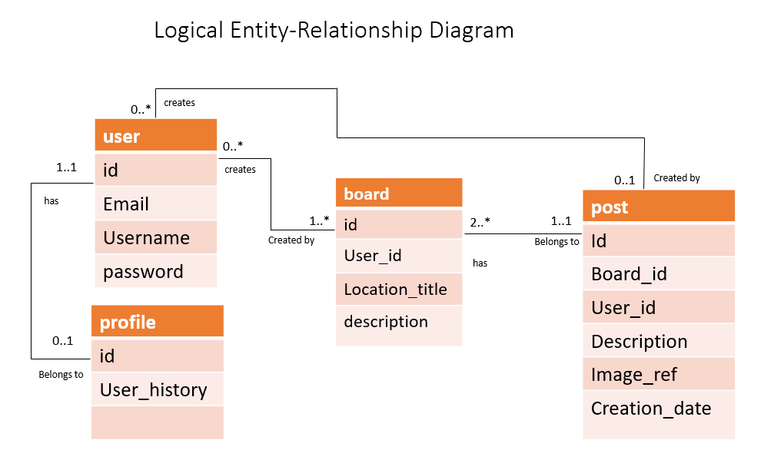

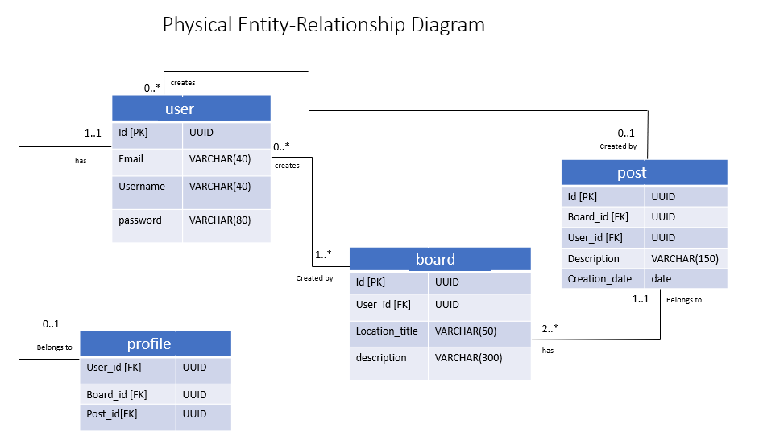

## Implementation

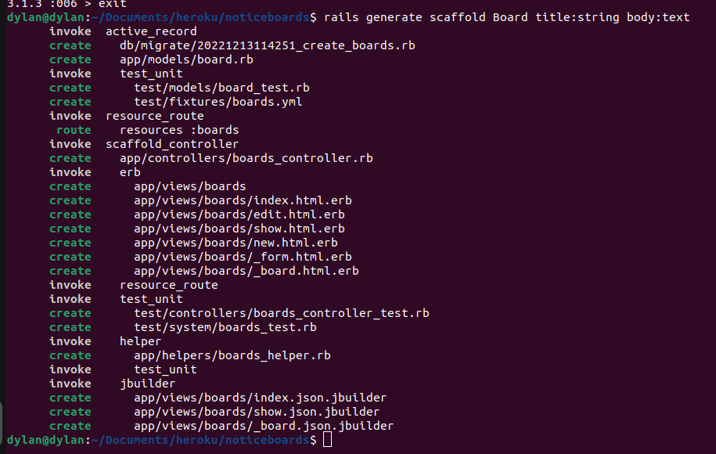

## Design Patterns

# Testing

# Deployment, Continuous Integration and Delivery Strategies

Git

Git is an open-source distributed version control system (DVCS), developed by Linus Torvalds. Git is used in a vast quantity of software projects. Git manages information in repositories which by default contain the full history of all changes, enabling a flexible and collaborative workflow.

Github

Heroku

Heroku is a container-based cloud platform as a Service which allows developers to deploy, manage and scale web applications in a flexible way. Heroku offers the necessary language and environment supports to deploy ruby on rails web applications.

Using the Heroku CLI with Git to create the Heroku app for deployment

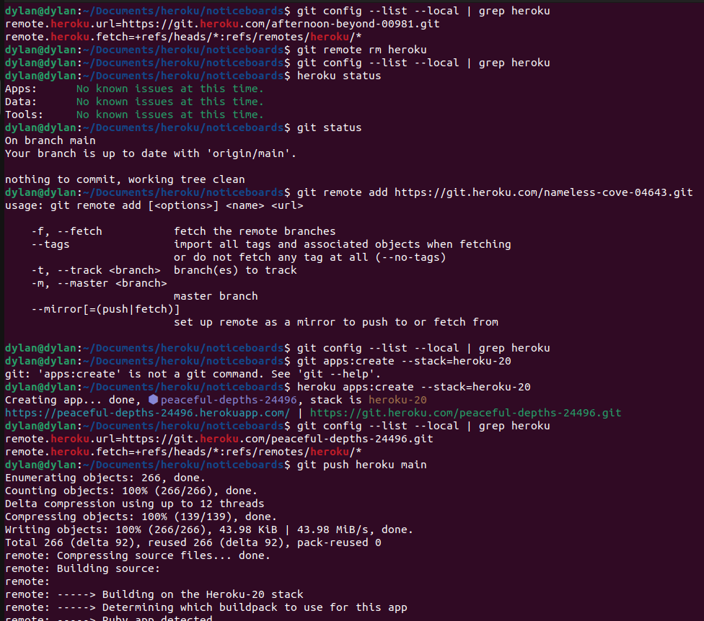

Heroku run rake db:migrate - T his command creates the database, this application uses a Postgresql database.

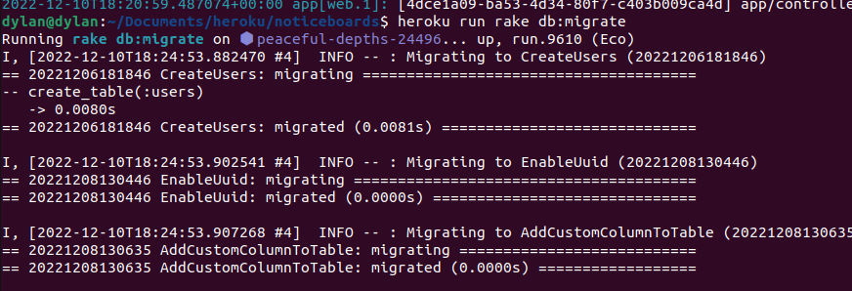

Bibliography

[1] heartcombo, “GitHub - heartcombo/devise: Flexible authentication solution for Rails with Warden.,” *GitHub*, Jun. 27, 2022. https://github.com/heartcombo/devise (accessed Oct. 11, 2022).

[2]

faker-ruby, “GitHub - faker-ruby/faker: A library for generating fake data such as names, addresses, and phone numbers.,” *GitHub*, Nov. 08, 2022. https://github.com/faker-ruby/faker (accessed Oct. 11, 2022).

[3] “Merriam-Webster Dictionary API,” *Dictionaryapi.com*, 2022. https://dictionaryapi.com/ (accessed Oct. 15, 2022).

[4] OpenWeatherMap.org, “Weather API - OpenWeatherMap,” *Openweathermap.org*, 2017. https://openweathermap.org/api (accessed Oct. 15, 2022).

‌

‌

‌